Suits By Sassy
Men’s Bodybuilding
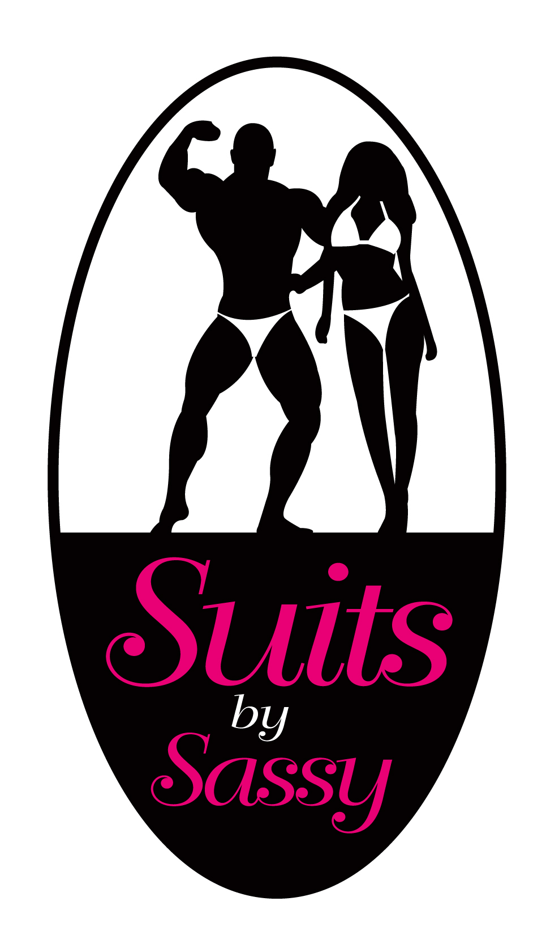

Name _____________________________________________Date________________

Address________________________________________________________________

City /State/ Zip

Phone:________________ Email:___________________________________________

Date NEEDED__ _____________(This date should be before your show date)

Organization/Federation_______________________

Trainer___________________________ Trainer Cell#____________________
Suit Styles and measurements

Standard Fit- 1 Inch sides with fuller front and back
Flex Fit- ½ Inch sides with narrower front and back
Brazilian Fit- 3/8 Inch sides with narrowest front and back

Small- 28-30 Inch waist
Medium 31-33 Inch waist
Large 34-36 Inch waist
Extra Large 37-40 Inch waist

Measurements:
Waist at belly button________________________

Hips at widest part of the glutes___________________________

What color/s (swatches) of material would you like your suit made of?

Men’s suits are $45 and include free shipping!

Suits by Sassy

Terms and Conditions

I______________________________________(client’s full name), the undersigned, hereby acknowledge that I have placed an order with Suits by Sassy and it is designed to suit my requirements (i.e. color, fabric, and measurements). I know that I am responsible to submit a non-refundable deposit. I am also aware that no work on my order will be started until the 50% deposit has been received by Suits by Sassy, in a timely manner, or Suits by Sassy cannot guarantee that your suit will be received on time. Shipping charges will apply (unless arrangements are made to pick the suit/s up from Suits by Sassy) and will be included on the original quote given by Suits by Sassy as part of your total order.
Final payment is due upon notification that your order is ready for decoration and must be received before that order is shipped or picked up from Suits by Sassy.

I also am aware that because it is a custom order, if for some reason I decide to not compete or can’t compete, suffer an unforeseen injury which causes me not to be able to compete, change my mind on the agreed design, color or fabric, for any reason decide that I no longer need the ordered item/s, that it is my full responsibility to provide Suits by Sassy with full payment for the order, regardless of any circumstantial event or reason that may cause me not to compete.

I am also aware that Suits by Sassy can cancel my order at any time and that I will receive only my previously paid deposit back. Suits by Sassy is in no way responsible to ship/deliver anything other than my original deposit.

Suits by Sassy is not responsible for the durability of the fabric, ornamentation and laundering of the suit/s. Recommended washing treatment is suggested but will not guarantee that fitness products such as tanning products or oils can be washed off the suit/s or will not cause damage to fabrics.

I have read and accept the terms and conditions of the sale.

Signed by:_______________________________________

Date:____________________

Visa Master Card Amex Discover

Credit Card#_____________________________________________________

Expiration Date: _______________________ CVV#__________________

Billing Address for Card
Street Address____________________________________________________
City/State/Zip Code________________________________________________

